Balu's Study Pro: Detailed Project Flowchart

This walkthrough provides a comprehensive visual and technical breakdown of the Balu's Study Pro ecosystem.

- High-Level System Architecture

The project follows a Modular Agent-Based RAG (Retrieval-Augmented Generation) architecture. It bridges the user's local documents with powerful LLMs via lightning-fast vector search and specialized AI agents.

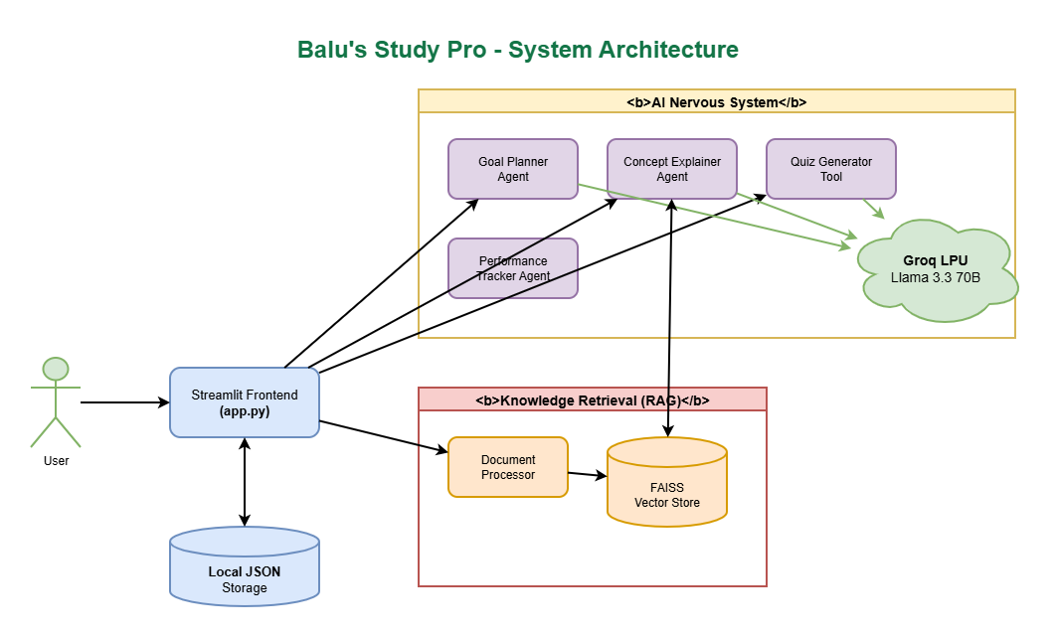

- User Journey Flowchart

This diagram illustrates the typical workflow a student follows when using the application.

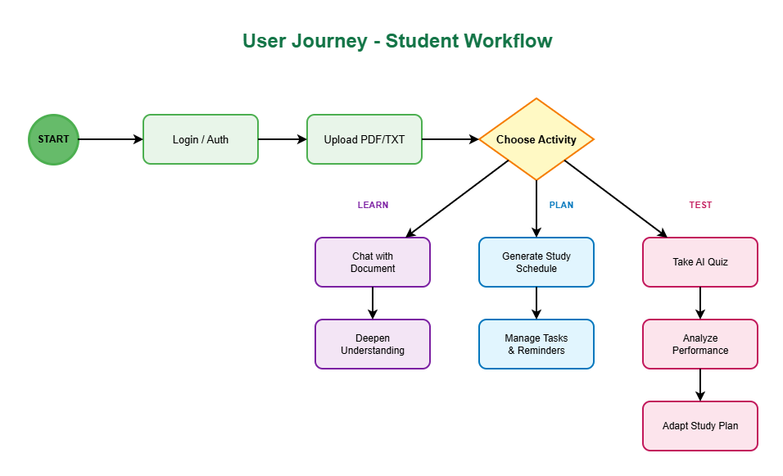

- The RAG Pipeline (Data Flow)

The "Magic" of the system lies in how it processes documents to provide context-aware answers.

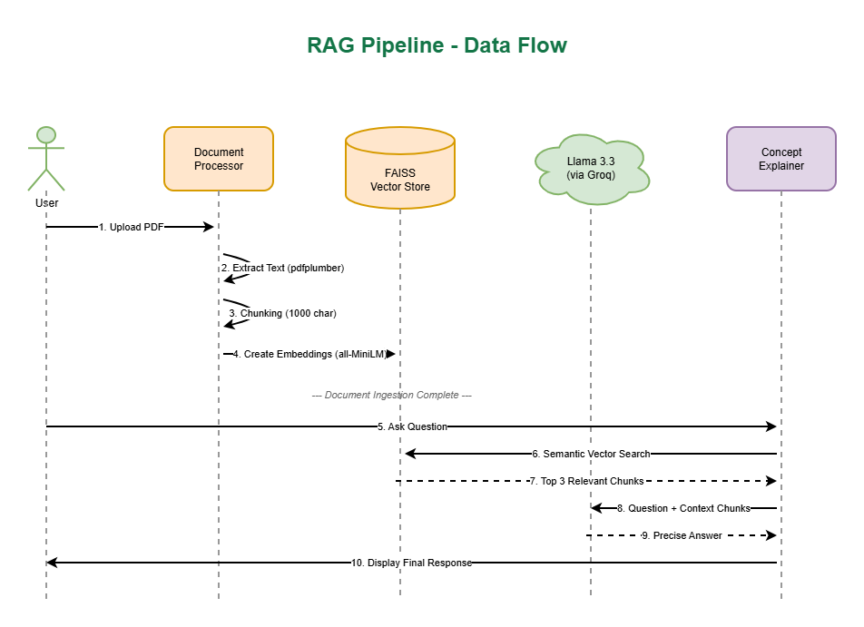

- Specialized Agent Logic

Each agent has a specific internal loop to ensure high-quality outputs.

